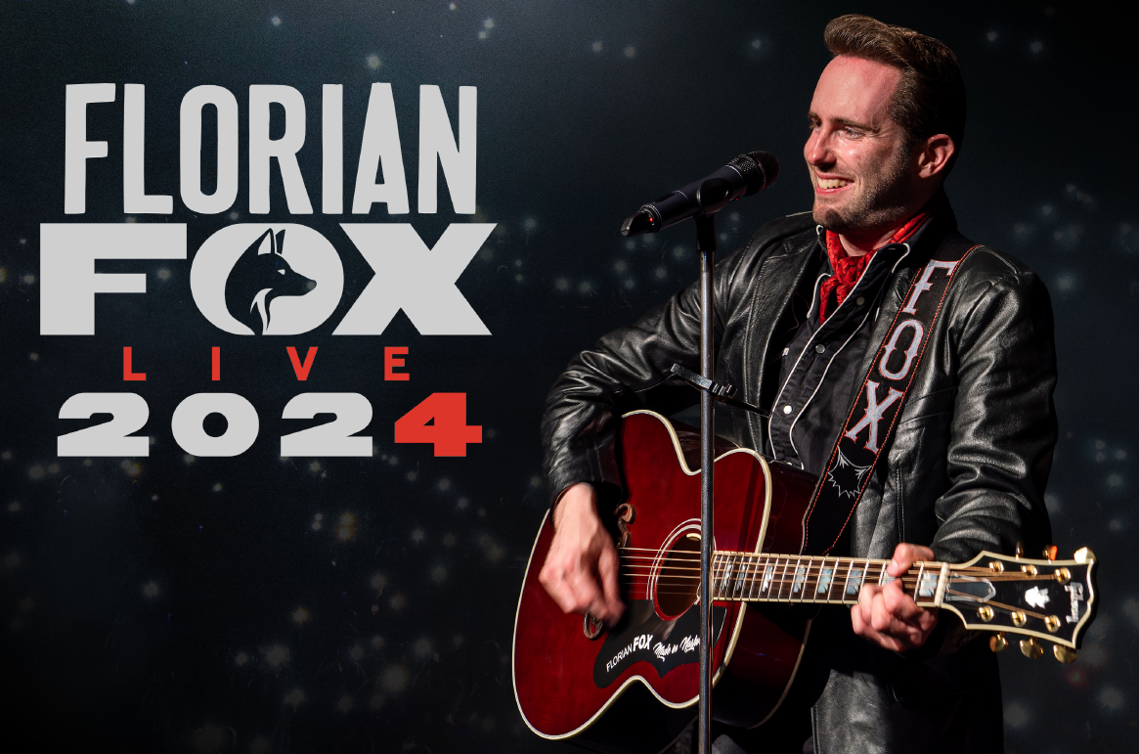
Florian Fox
Vocalist – Performer – Songwriter | Texas Sounds Int. Country Music Award Winner
Florian Fox is often referred to as the "Swiss Johnny Cash" due to his powerful bass-baritone voice.
At the age of 15, Swiss country singer-songwriter Florian Fox formed what was then Switzerland's youngest country-rockabilly band, "The Black Barons". With the band he won a Swiss newcomer award and the band's album was called one of the best Swiss albums of 2013 by Swiss national radio SRF 3. He has opened for acts such as The Bellamy Brothers, Lorrie Morgan, Johnny Reid and many more.
In 2020, in the midst of the pandemic, Florian Fox moved to the country music capital of Nashville to take his musical career to the next level. In October 2020, he won the award for "Outstanding Live Performance" at the Texas Sounds International Country Music Awards in Jefferson, TX. In Nashville, his first solo album "Made in U. S. A" was produced by U.S. country music star Chuck Mead (BR5-49, Musicians' Hall of Fame). The album was released on May 13, 2022, both as a vinyl LP and on all digital platforms.
Florian Fox is setting out for the great leap: The single release, 'Swiss Guy', published in early 2022 was a full-scale success, with its accompanying music video, in which Fox humorously re-enacts experiences of his early days as a Swiss guy in Nashville, achieving over 30,000 views within days. In February, he appeared on the U.S. Outlaw Country Music Cruise alongside Chuck Mead. The line-up of the Outlaw Cruise included legends such as Rodney Crowell, Emmylou Harris, Carlene Carter and Mead himself. In June 2022, he played a U.S. tour of Louisiana and Tennessee, which included in particular the world-famous Nashville honky tonks 'Robert's Western World' and 'American Legion Post 82'. The following tour through Switzerland regularly brought about sold-out venues and concert halls.
2023 saw the release of Florian Fox's EP "Made in Nashville". The EP which was dedicated to roots music featured former Johnny Cash bassist Dave Roe, Country Music Hall of Fame member Charlie McCoy and Grand Ole Opry music director Kerry Marx. The 2023 tour of the U.S. states of Alabama, Louisiana and Switzerland regularly brought Florian Fox sold-out auditoriums and included some of the most prestigious country music festivals on both sides of the Atlantic. In particular, Florian Fox thrilled audiences on the main stage of Country Night Gstaad together with US superstar Miranda Lambert and other top acts. He was also headliner of the 1st Country Music on the River cruise on the Danube.
On February 24, 2024 Florian Fox released his first live album "Live At Country Night Gstaad". He is a nominee for the renowned Swiss cultural award Prix Walo and the Texas Sounds Int. Country Music Awards in 2024.
Florian Fox is a member of the Country Music Association (CMA) and the Americana Music Association. Since April 2022 Blick (Ringier) has been his official media partner.
Website: www.florianfox.com | Instagram: florianfox.music | Facebook: florianfox.music Booking and Management: Show & Music AG, Int. Artist Agency, P.O. Box, 8047 Zürich matter@showandmusic.ch +41 (0) 44 461 00 66
Selected Press: www.florianfox.com/press
Switzerland: Blick, SRF Gesichter & Geschichten, Schweizer Illustrierte, Schweizer Familie, Tages-Anzeiger, Zürcher Tagblatt, Basler Zeitung, Berner Zeitung, Der Bund, Thuner Tagblatt, Zürichsee Zeitung, Radio SRF 1, Radio Zürisee, SRF Swissinfo, CountryStyle, Thurgauer Zeitung, St. Galler Tagblatt.
USA: Eagle 98.1 The Rock Station, Radio 107.1 The River (Faraday, Louisiana), Radio 90.7 FM WWOZ (New Orleans, Louisiana).
Nashville/Zurich, March 2024
 | Booking & Management | Official Media Partner
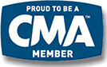 |  | 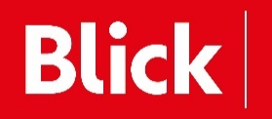
Nominiert für

